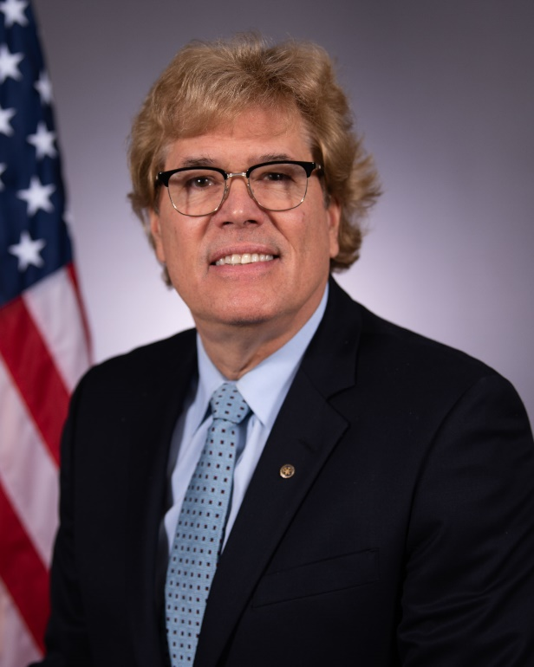
Dan Shea
187th Fighter Wing
Director of Psychological Health
MPA, MSW, LCSW, LICSW, PMP

January 25, 2022

A DPH Message of Hope – Saving Lives and Prospering Lives

If asked what your priorities are, the average Airman may say family and friends, the guard and work. Presently there are struggles with all three. Amn Smith is emotionally spent, physically drained and has become numb to thought of feeling. Family starts to notice that anger is easily kindled and rested nights are few and far between. Living with the weight of this has become the new reality. Yet Amn Smith does not seek help. We have all been told that getting help represents strength, not weakness, yet we tend to not seek support. Why is that?

The answer is what I call the “military resistance cycle.” As a Veteran myself, I know that the only tolerable percentage of harm that Airmen are willing to take to their career is ZERO. You work too hard and sacrifice too much to tolerate any perceived risk. This well-earned apprehensiveness and risk averseness can impair an Airmen’s understanding of the confidential protections that are hallmark of the Directors of Psychological Health (DPH) Program. What naturally happens with untreated stress or when we are struggling? As a Director of Psychological Health, I know if things don’t get better, they get worse. Airmen are actually harming their own careers themselves when they resist reaching out for help, and don’t even know it. Their distress reactions begin to manifest and harm their military job, civilian job and personal life. This resistance cycle ultimately leads to self-actualizing what they were trying to avoid; others (chain of command, employer, family, friends) finding out the truth. The resistance to seeking help can lead to hopelessness and despair, which are the primary factors for a person harming themselves.

So How Can We Save Lives and How Can We Prosper Lives?
1. Early Intervention Saves Lives and Prospers Lives. The answer in military culture is found in one word – Trust. Ask any group of military members or Veterans to provide one word to describe the military culture? Yes, you will get many answers. However, they will ALL agree on the significance of that word being “Trust”. In our culture, what happens when someone we trust walks in the room, or calls? Everything changes. A DPH is that trusted person. The DPH represents an entire system of early intervention and continuum of care for any service member. DPH’s seek and collaborate with members on the single resource that is absolutely compelling for their pathway to improving and managing life (emotions, relationships, trauma).

2. Healthy Connection to Others Saves Lives and Prospers Lives. Connections with others is a necessary part of the human condition. As human beings, we are built to connect with others, and form communities. Connecting with others is crucial to our physical and mental well-being. We suffer without human connection. Connection is also crucial for saving lives. All of us can prosper as individuals when we have a sense of connection and belonging in our lives. Those with healthy connections usually don’t die by suicide. When we build teams, it brings strength to each of us as individuals. A service member connecting with the DPH will build an immediate team of support and individualized resources. Airman can learn for themselves their own unique strengths, abilities to manage their emotions, relationships, and unleash their fullest potential. Every Airman is in charge of their own Support Team, but the DPH can help build your roster. The goal of the DPH is not to take you out of the fight, but to help you be at your best to stay in the fight.

3. The Greatest Protection against the Suicide Impulse is Hope.

Catastrophic thinking is always temporary. Any counselors reading this article are highly aware that saving lives is a team activity. We also know how Airmen are overwhelmingly grateful after their life is saved from the senseless act of suicide. The reason is simple – catastrophic thinking is always temporary. Suicide survivors know best – Every Life is worth saving and living. Survivors are living testimonies to this. They can explain how everything that happened to them; addictions, trauma, depression, grief, loss, disappointments and risky behaviors, can all lead to hopelessness and despair. It’s those very words and conditions that can cause catastrophic thinking. We begin to believe we might be better off dead than alive. A DPH can help you with building a bridge from hopelessness to hope. Hope signifies the most powerful positive emotion in all our lives. Hope changes how we think, how we feel and how we act. Hope saves lives. It is the bridge to discovering our inner purpose and meaning for our lives.

4. Who Can Help?

The Director of Psychological Health. All Airmen have ready access to the Director of Psychological Health and the system of resources and support teams they provide. These resources focus on supporting a person’s ability to identify and build their unique inner strengths and have clear and engaging meaning and purposes for their lives. As a DPH I have learned that helping a person with suicidal thoughts is not a resource problem, it’s a coordination problem. We exist to coordinate resources and personalize them for the unique needs of every individual Airman. My “ask” of every Airmen is that they “trust in the process.” Trust the DPH system of hope, support, connection and resources. In doing so, you can learn for yourself that you are fully in charge, and the DPH works with you and for you.

Remember... if you’re not getting better, you’re getting worse. Early intervention can literally “cut off” any process that can lead to catastrophic thinking. The DPH system of Hope, Support, Connection and Resources saves lives and changes lives. Take the time to learn and use your DPH resources to start a trusted relationship that will prosper in your military, civilian and personal lives.

